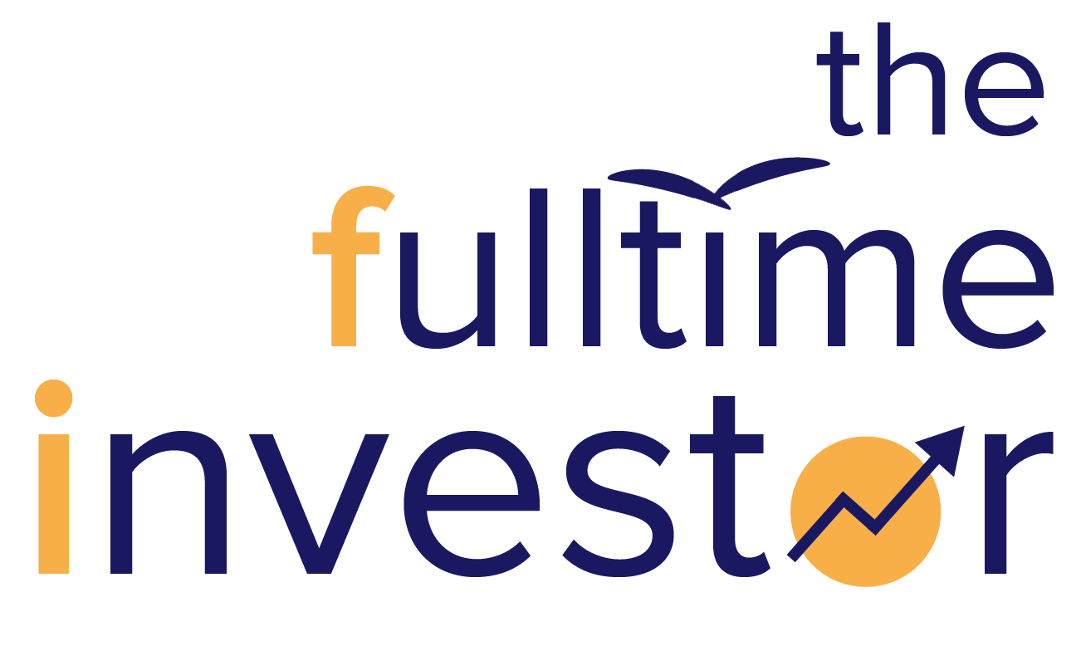
WORKBOOK

Name: ___________________________________________

Welcome to GIM Online! Before you begin the course please take some time to fill up the next page with your name and your goals.
DO NOT skip this exercise as most people who are successful in learning investing have a strong why. This is a necessary step to increase your chances of success and help you become a better investor.
Happy Learning!

________ ‘s Investing Journey
or _________’s Promise

My biggest WHY’s - I want to learn investing because…

My goal(s) for completing this course

(Goals must be achievable, measurable, and be achieved within a set time frame. ‘I want a better life and future’ doesn’t cut it!! BE SPECIFIC SO YOU CAN MEASURE HOW FAR YOU’VE COME!)
e.g. I promise to myself that by _____ (date) that I will ‘retire’ my dad from a 7-day work week to a 5-day work week. To achieve this I will take the follow steps :

After I have completed the Program, I will….
(e.g. open a brokerage account, encourage my friends / family to think of their financial health, etc)

I promise to learn, ask questions on the community messaging platform, and do my best to fully understand and complete every module in this Growth Investing Mastery Program. I am committed to my financial success!

Signed ________________

Date ________________
Content Page
1.1 Introduction 5
1.2 Income Statement Structure 6
1.3 Gross Profit Margin 9
1.4 Operating Profit Margin (or EBIT Margin) 12
1.5 Earnings Before Interest and Tax 15
2.1 Introduction to Balance Sheet 17
2.2 Importance of Balance Sheet 19
2.3 Net Debt To Equity 21
2.4 Return of Equity (ROE) 23
3.1 Introduction to Cash Flow Statement 26
3.2 Importance of Cash Flow Statement 28
3.3 Life Ratio 30
3.4 Vampire Ratio 32
3.5 Cash Conversion Cycle 35
2.1.0 Potential To Scale: Total Addressable Market 40
TOTAL ADDRESSABLE MARKET 40
2.1.1 Potential To Scale: Ease of Scaling 42
PROFITABLE GROWTH 42
SCALABLE GROWTH 44
OPERATING LEVERAGE 46
2.2 Awesome Quality: Introduction 48
2.2.1 Awesome Quality: Website 54
2.2.2 Awesome Quality: Facebook 55
2.2.3 Awesome Quality: Instagram 56
2.2.4 Awesome Quality: YouTube 57
2.3 Continuous Compounding 58
2.4 Safety Introduction 61
2.4.1 Key Man-Risk 62
2.4.2 Customer Risk 65
2.4.3 Regulatory Risk 68
2.4.4 Valuation Risk 70
3.1.1 Growth Mindset 73
3.2.1 Ability to Execute 75
3.3 Skin In the Game 78
3.4 Purpose 81

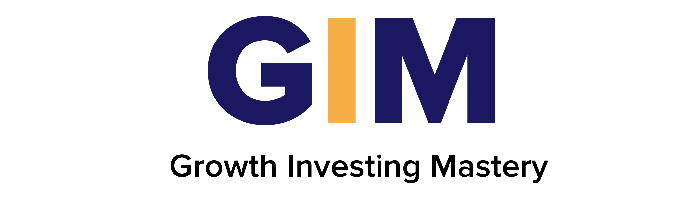

1.1 Introduction
- What have you learned about facts vs opinions in this module? Write them below.

- What must we consider before putting money into a business?

- List 4 to 5 companies you are interested to invest in. Take some time to really consider the companies YOU are interested in. We will return to this list often during the Program modules. Don’t proceed to the next module before completing this item. If you already have a portfolio, list the companies on your portfolio.

Along the way, it will be beneficial to you to apply what you learn to this list of companies. This Workbook will guide you in the process of doing so.

1.2 Income Statement Structure

- Test yourself! What are the items in an income statement? Write down as many as possible!
R
C
G
S
G
A
E
I
T
O
N

- In the Profit & Loss statement, sales generated by the company is called R________

- What is Cost of Goods Sold (COGS)?

Direct costs of P________ the Goods Sold by a company.

- Examples of operating expenses include Sales and Marketing, General Expenses, and Admin Expenses. Give two examples of each type of expense below.

  - Examples of Sales and Marketing -
  - Examples of General Expenses -

  - Examples of Administrative Expenses -

Answers:
- Revenue, cost of goods sold, gross profit, selling and marketing, general expenses, admin expenses, earnings before interest & tax, interest expenses, taxes, one-off gains and losses, net profit
- Revenue
- Producing

  - Advertising, Sales commissions
  - Utilities, Rent, Transportation, Travel, Amortization, Depreciation, Rent and Repairs,
  - Payroll ( Salaries and wages), Employee benefits and Pension contributions

1.3 Gross Profit Margin

- If McDonald's revenue is $50,000, Cost of Goods Sold are $20,000 and Operating Expenses are $10,000, then what is their Gross Profit?

Hint: $Gross Profit=Sales Revenue -Cost of Goods Sold$
Answer:

- Amelia owns a hipster café. In 2019, the café posted the following Income Statement. Use the information below to calculate Amelia's Gross Profit Margin, or GPM (round answers to 1 decimal place, in %)

Hint: $Gross Profit=Sales Revenue -Cost of Goods Sold$

Sales Revenue | $120,000
Cost of Sales | $67,000
Gross Profit | $53,000
Net Profit | $15,000

Answer:

- Michael manufactures and sells furniture from his carpentry workshop. The Income Statements for his company for the last three trading periods are shown below.

Year | 2017 | 2018 | 2019
Sales Revenue | $69,570 | $76,525 | $81,275
Cost of Goods Sold | $43,750 | $45,625 | $46,530
Gross Profit | $25,820 | $30,900 | $34,725

  - Using the information above, calculate the Gross Profit Margin (GPM) for each of the three years shown. (Round your answer to 1 decimal place)

Answer:

  - Explain what is happening to Gross Profit Margin between 2017 to 2019 (Is it increasing or decreasing?)
Answer:

- Why is Gross Profit Margin important in analysing a business?

Answers:
- Gross profit= $30,000
- 44.2%
- a) GPM 37.1% (2017), 40.4% (2018), 42.7% (2019)
b) Increasing, so the business is improving in terms of the profits made from the furniture produced.
- GPM is an indicator of the pricing power of a business. A business with pricing power has a competitive advantage (superpower), and can command a premium for its products.

1.4 Operating Profit Margin (or EBIT Margin)

$Operating Profit \left(EBIT\right)$
$=Revenues-Cost of Goods sold -Operating Expenses(SG\&A)$

$Operating Profit Margin = Operating Profit (EBIT) / Revenue$

- Ben works as a financial analyst for Boogle. He wants to evaluate the profitability of Boogle’s operations. The Income Statement for Boogle in 2019 is shown below.

Year | 2017
Sales Revenue | $10,000,000
Cost of Goods Sold | $5,000,000
Gross Profit | $5,000,000
Operating Expenses (SG&A) | $500,000

  - Calculate the Operating Profit (EBIT).

Answer:

  - Calculate the Operating Profit (EBIT) Margin (%). Does Boogle’s Operating Profit Margin fulfill our criteria of > 8%?
Answer:

- One Financial year consists of 4 quarters. Jimmy is looking at 2Q'19 (2nd Quarter, 2019) for Picolo, a software company that he’s thinking of investing in. Which 4 quarters should he look to determine the Trailing Twelve Months (TTM) of Picolo?

2Q'18 | 3Q'18 | 4Q'18 | 1Q'19 | 2Q'19 | 3Q'19

Answer:

- Pick a company that you are interested in (from the list you made earlier).
Go to Morningstar.com, check the Operating Profit Margin (%) of the company that you like on the GIM calculator. Does it pass the criteria?

Answers

  - 4,500,000
  - 45%, Yes
- 3Q’18 to 2Q’19

1.5 Earnings Before Interest and Tax

EBIT (Operating Profit) Criteria: Increasing EBIT (Operating Profit) for the past 2 years (>10%)

- Why do we want an increasing EBIT (Operating Profit)?
Growth in EBIT (Operating Profit) influences g________ in share price.

- The figures below represent the earnings of company A and B over time.

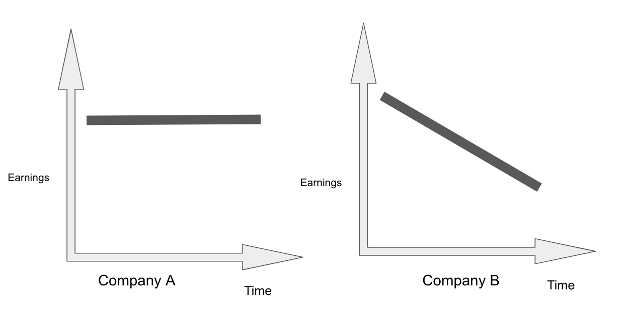

Which company would you invest in? Explain your answer.

Answers
- growth
- Neither. Company A’s earnings are stagnant and Company B’s earnings are falling over time. Remember, we only invest in companies that can grow their earnings!

2.1 Introduction to Balance Sheet

- List some assets and liabilities that Mr Macho might have.

- What does the balance sheet comprise of? Fill in the main sections on this diagram:

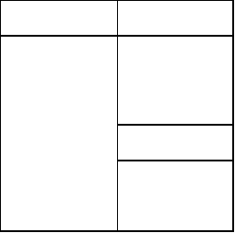

- Circle the Assets and Cross out the Liabilities in the table below.

Cash | Loan | Receivables
Equipment | Payables | Property

- Does the stock price of a business affect its balance sheet?

Answers
- Refer to this module’s online video.
- Current Assets, Non-Current Assets, Non-Current Liabilities, Current Liabilities, Equity
- Circle: Cash, Equipment, Receivables, Property. Cross: Loan, Payables.
- No. The balance sheet depends on the fundamentals of the business like debt, cash and equity, etc. The sooner we understand that stock price has no effect whatsoever on the actual business operations, the quicker we can rationally analyse and determine what we want in a great company.

2.2 Importance of Balance Sheet

- What might happen when an investor looks only at the income statement and not the balance sheet?

Answer
- The income statement tells us how profitable a company is, but it doesn’t show us the debt situation of a company (which is shown on its balance sheet). A highly profitable company can potentially go bust because of high debt.

2.3 Net Debt To Equity

$Net Debt to Equity Ratio = \frac{Total Debt- Total Cash}{Total Equity}$< 0.4

- FaceFile has $10 million of Debt, $6 milion of Cash, and $40 million of Equity. What FaceFile’s Net Debt-to-Equity (ND/E) ratio?

- Valerie’s hair salon has a Net Debt-to-Equity (ND/E) ratio of 0.6. What does this mean?

- When calculating Total Debt, do you include items such as payables (i.e. money owed to suppliers)?

- Exercise: Pick a listed company that you are interested in from the list you made earlier.
Go to Morningstar.com, fill up the Net Debt-to-Equity (ND/E) ratio for your chosen company on the GIM calculator.

Does it pass or fail our criteria?
If you have no companies in mind, use Microsoft as an example.

Answers
- 10%
- The company has a Net Debt of $0.60 for every dollar of Equity it has.
- No, payables such as money owed to suppliers is not included. We only look for Debts which are interest-bearing (i.e., bank loans where interest is paid on the amount borrowed). For payables, most suppliers do not charge their customers interest with the (typical) 30 day payment terms.

2.4 Return of Equity (ROE)

$Return on Equity = \frac{Net Income}{Total Equity}$> 15%

- If a company called PaySend has a Return On Equity (ROE) of 25%, what does this mean?

- Return on Equity is Net Income / Total Equity. Circle below where we can find Net Income and Total Equity.

Balance Sheet | Income Statement | Cash Flow Statement

- Look at the table below, and fill in the blanks.
 | Microsoft | Apple
Total Equity, USD billions | 110 | 89
Net Income, USD billions | 44 | 57
Return On Equity | ___________ | ____________

Which company has a better Return On Equity (ROE) ?

- Comparing an asset-heavy business (e.g., a manufacturing company) with an asset-light company (e.g., a software company,) which do you think would have a higher ROE, and why?

- Why is ROE an important metric for investors to be profitable in investing?

- Why can a company with a low EBIT Margin still be a good company? Explain as best as you can.

Answers
- It means that for every dollar that PaySend’s business owners put into the business, the business generates $0.25. This metric measures how effectively the management of PaySend is using its equity to generate profits.
- Circle: Income Statement (Net Income) and Balance Sheet (Total Equity)
- 40%, 64%. Apple has a better ROE
- Asset-light businesses like software companies usually have higher ROE. To increase earnings, the owners of an asset-light business do not need to sink more capital (Equity) into the business to support growth. On the other hand, an asset-heavy manufacturing company would need to buy more machinery / equipment or hire more people. For example, for Microsoft to sell another license, there is no need to buy additional equipment (their product is not physical), or invest more money in new software. Being able to earn more money using lesser capital, asset-light businesses tend to have a higher ROE.
- ROE is very similar to ROI. When a business has a high ROE, it means the business is generating more returns(Net Income) for its owners. So in the long run, this will make our businesses more valuable, and the stock price over the long run will reflect this as it goes up.
- Companies with low margins can still show a very decent ROE if they have extremely high volume of sales.

3.1 Introduction to Cash Flow Statement

- Which 3 Cash Flow activities does the cash flow statement include? Fill in the triangle below.

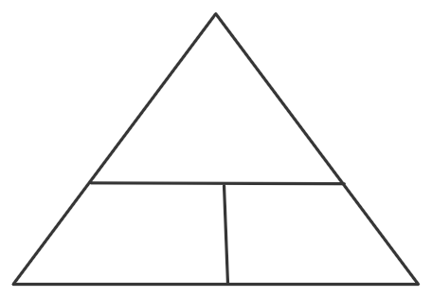

Answers
- Cash Flow from Operations, Financing and Investing

3.2 Importance of Cash Flow Statement
- At which point does a company record its profits?

- Why is the Cash Flow statement important?

Answers

- Profits are recorded when a company delivers goods or service (even when cash has not yet been collected) from the sale of goods or service.
- It shows us whether profits recorded are really collected in cash.

3.3 Life Ratio

$Life Ratio =\frac{Cash Flow from Operations}{Net Income}$ > 0.8

- Calculate the Life Ratio of Sturing Corporation below. Does it meet our criteria of more than 0.8?
Sturing Corporation | Cash Flow from Operations | Net Income
Sturing Corporation | $150,000 | $120,000

Life Ratio = ____________. Pass / Fail ?

- In layman terms, what does a Life Ratio of 0.7 mean?
- If we have a company with a Cash Flow from Operations of -$8 mil, and a Net Income of -$10mil, we get a Life Ratio of 0.8. Does this company pass our criteria?

- Why do certain companies have a Life Ratio of more than 1?

Answers
- 1.25, Pass
- It means for every $1 of profit the business recorded, the company received $0.70 in cash.
- No. The entire point of Life Ratio is to see if a company has healthy cash flows coming in. Do not apply the formula blindly - it’s important to understand the real principle behind it. If a company has negative cash flows from operations, it fails the criteria immediately.
- Companies with a Life Ratio more than 1 are usually companies that collect revenues in advance. When companies collect revenues in advance (e.g., loyalty cards such as Starbucks cards that customers top-up before use), they cannot recognise this cash flow as profits because services or goods haven’t been delivered. Thus, cash flows will be higher than net income.

3.4 Vampire Ratio
$\frac{Capital Expenditure (CapEx)}{Cash Flow from Operations (CFO)}< 0.5$

- Capital Expenditure is the cost that a company spends to acquire, upgrade, and maintain its physical assets to keep the business running. These physical assets can be in the form of P_________, P_________ or E_________.

$Free Cash Flow = CFO - Capex$

- Why is Free Cash Flow more important than Cash Flow from Operations (CFO)?
- Why must we look at Free Cash Flow and account for items like maintenance cost? Aren’t maintenance costs already reflected in Expenses on the Income statement?
- Kelvin owns a car manufacturing company called Ferrabi. Calculate Ferrabi’s free cash flow with the information below.
Cash flow from operations = $150,000
Net Income = $130,000
Capital Expenditure = $100,000
Free cash flow =

- Circle the correct answer. We would want to buy companies with
Good cash flow from operations / Good free cash flow ?
- If a company has a Vampire Ratio of 0.8, what does it mean?
- Why do low CAPEX companies have better growth prospects compared to high CAPEX companies?

Answers
- property, plant, equipment
- Free cash flow is more important because it tells us the real cash flow situation of a business after paying for necessary items (e.g., maintenance). Singapore Airlines can show nice positive cash flow from operations, which doesn’t account for CAPEX. But once you look at the company’s CAPEX, you will see that it is cash-strapped.
- This is the interesting part about accounting. If you own a manufacturing plant, and you constantly have to upgrade or maintain old machines to keep them functioning efficiently. In the eyes of accounting, this amount spent to upgrade and maintain old machines will be recorded under assets because with this upgrade, your assets (machines) are more “valuable”. So on the financial statements, the business will not recognise this upgrade as an expense. However, in the eyes of business owners, if a business forces owners to reinvest earnings otherwise the business can’t maintain their competitive edge or continue their business operations (in this case, your machines), this should be treated as a real cost to business owners rather than an asset. Hence, we take CFO minus CAPEX as CAPEX is a real cost to us.
- $50,000
- Circle: Free cash flow
- It means that for every $1 of cash flow from operation that comes in, the business is forced to spend $0.80 on CAPEX.
- Because low CAPEX companies do not need to spend much on CAPEX, they have more Free Cash flow available for them to invest in future growth projects or plans.

3.5 Cash Conversion Cycle

- Explain these Cash Flow terms.
Payable days:
Receivable days:
Inventory Turnover days:

Formulas:
$\frac{Trade payables }{Cost of Goods Sold}$$× 365 Days = Payable Days$
$\frac{Trade Receivables }{Revenue}×365 Days = Receivable Days$
$\frac{Inventory}{Cost of Goods Sold}×365 Days = Inventory Turnover Days$
$Cash Conversion Cycle = Receivable Days- Payable Days < 130 Days$

Look at the table below.
 | Cash Conversion Cycle | Trade Receivables | Trade Payables | Cost of Goods Sold | Revenue | Average Inventory
Koko Kola |  | 2,281 | 5,290 | 8,195 | 23,104 | 1,424
Popsi |  | 3,261 | 5,357 | 14,176 | 32,562 | 1,693

- Calculate the Receivable Days of Koko Kola and Popsi.

- Calculate the Inventory Turnover Days of Koko Kola and Popsi.

- Calculate the Payables Days of Koko Kola and Popsi.

- Find the Cash Conversion Cycle of Koko Kola and Popsi. Does it pass our criteria?

- Circle the right answer. A Cash Conversion Cycle of 20 days implies:
A company is cash rich for 20 days | A company is cash strapped for 20 days

- A positive Cash Conversion Cycle is better than a negative cash conversion cycle.
True or False?
- Why is a long Cash Conversion Cycle bad? What are some implications of having a long Cash Conversion Cycle?

Answers

  - How long the company takes to pay their suppliers
  - How long it takes for the company to receive their sales on credit
  - How long it takes for a product to be sold
- Koko Kola: 36 Days , Popsi: 36.5 Days
- Koko Kola: 63.4 Days, Popsi: 43.6 Days
- Koko Kola: 235.6 Days, Popsi: 137.9 Days
- Koko Kola: -136.2 Days, Popsi: -57.8 Days
- Circle: A company is cash strapped for 20 days
- False
- When a business has a long cash conversion cycle, it means that a lot of their cash is either stuck in inventory, or they are unable to collect payments from customers promptly. So even for a business that is delivering good profits, the company faces a crash crunch. And if this company wants to expand, with a lot of their money stuck either with inventory or with customers, it would need to borrow money to finance growth. This debt would in turn stress the business’s balance sheets. An example would be property developers who usually carry high debt and have a high Cash Conversion Cycle (CCC).

Draw a mindmap of what you have understood from this module of quantitatively analysing a business. Make this a masterpiece you will continue to reference as you grow your portfolio!

Using the terms and calculations that you have learnt from Quantitative Analysis, apply these quantitative checks to the list of companies that you have prepared earlier.
After applying the quantitative checks, list the companies that have passed those checks. Keep this list! We’ll proceed on to learn about the qualitative checks too.
(Note, this is NOT a list of companies you can invest YET. We haven’t looked at the Qualitative criteria!)

2.1.0 Potential To Scale: Total Addressable Market

TOTAL ADDRESSABLE MARKET

- Size is the________________ of growth.
  - unit
  - friend
  - enemy

- Market capitalization refers to the company’s price. We prefer to go for companies with market capitalization between USD ________ million to below USD________ million.
  - 10, 600
  - 200, 500
  - 200, 3000
  - 200, 2000

- Find the market capitalization of Alphabet.

- Why is the total addressable market important when we assess if a company has the market to scale? Explain your answer.

- Comparing Microsoft (a software company) and Honma Golf (a golf equipment company), which company has a bigger addressable market? Circle your answer.
  - Microsoft
  - Honma Golf

Answers:
- c
- c
- Google “alphabet share price” on Google, then ctrl + f “mkt cap”.
- The total addressable market provides us with a view that the company enjoys a high growth rate because it is still smaller. At the same time, when a business has a small addressable market, its growth rate will start to fall once it reaches a certain size. We want to buy into companies poised and ready for strong growth that will continue for many years.

- Microsoft. There are more computer users than golf players in the world.

2.1.1 Potential To Scale: Ease of Scaling

PROFITABLE GROWTH

- When you buy into a business, you expect to buy into a growth company because it becomes more valuable over time. In some sense, apart from having a good company, you want to buy into companies with a growth of 10% or more in operating profits yearly.
Why is growth important in the qualitative analysis of a company?

- Thinking of famously successful companies such as Microsoft, Amazon.com or Disney, select one and write down some ways they are able to grow.

An example of Facebook has been done for you.

CASE STUDY 1: Facebook 

- Raise prices of goods → increase prices of the ads
- Sell more of existing products → Sell more Ads and take in more clients
- Sell more products → Sell instagram stories
- Expand
Inorganic → Acquire Instagram or Expand into more countries
Organic → Facebook Audience and outreach is expanding for businesses

My Case Study: ________________ (company name)
Raise price of goods: ________________________________

Sell more of existing product: ________________________________

Sell more products: ________________________________

Expand: (organic)________________(inorganic)________________

Answers:
- Without growth, it is difficult for a company to increase its intrinsic value. Our aim of buying good companies is to enjoy capital appreciation over the long run. For that to happen, growth is essential.
- Case study: Microsoft
  - Raise Price of good by: Raising subscription prices
  - Sell more of existing product by: Selling more of their data warehouse solutions,
  - Sell more products by: Sell newer laptops or softwares.
  - Expand organically: By partnering with channel partners (i.e Microsoft partnership with Plaid in the Fin Tech industry).
  - Expand inorganically: Acquiring other companies

- Case study: Amazon
  - Raise Price of good by: Raising prices on advertising fees
  - Sell more of existing product by: Selling more items on their platform
  - Sell more products by: Adding new and different categories of items
  - Expand organically: Entering into new countries.
  - Expand inorganically: Acquiring other companies (such as Whole Foods)

- Case Study: Disney
  - Raise Price of good by: Raise ticket admission prices to their theme parks
  - Sell more of existing product by: Selling more park tickets
  - Sell more products by: Introducing new products (such as Disney+)
  - Expand organically: Open new theme parks around the world
  - Expand inorganically: Acquiring other companies (such as Marvel and Pixar)

SCALABLE GROWTH

- What are some key ingredients to measure a company’s potential to scale?
  - the age of the CEO
  - the size of the company
  - the presence of a franchise system or ability to use technology
  - b and c only

- Good companies have the ability to scale and sustain growth without a negative impact on the quality of their product and service offerings. Unlike traditional brick and mortar businesses, Netflix is a business which is able to scale with minimal impact on quality of service or it does not require adding tremendous costs.

Why do you think Netflix has great potential to scale? (Research Netflix on Google)
Hint: what is the population size of the world and how many subscribers are on Netflix?

Answers
- b and c only
- Netflix has a scalable, low-cost business model designed to maximize revenues and minimize costs. As they continue to expand their subscriber base, they are able to leverage operational changes in a cost effective manner, which further reduces operating costs on a per subscriber basis. Such cost reductions include increased automation and vendor negotiating leverage.

OPERATING LEVERAGE

- Operating Leverage is earning incremental profits without incremental
  - Cost
  - Revenue
  - Profit
  - Expenses

- When we assess a company’s potential to scale, the three most important factors are:
  - size of the company, growth rate of the company, total addressable market
  - the location of the company, the growth rate of the employees, total addressable market
  - the age of the founder, growth rate of the company, total addressable market
- There are two kinds of growth - low quality growth and high quality growth.
ShortCut Corporation has a gross profit of $50,000 and operating expenses of $30,000. The operating profit is $20,000.

The shareholders of ShortCut Corporation complained and the management felt pressured to report higher profits. They decided to cut their operating expenses down to $23,000. As a result, their operating profit increased to $27,000.
In this situation, is this high quality or low quality growth?

- Is a high or low quality growth preferred? Share your thoughts!

Answers
- d
- a
- It is low quality growth. The growth came from cutting expenses within the business. There is a limit to how much costs the company can cut before it starts to negatively impact the operations of the business. We want to have sustainable growth.
- As investors, we prefer high quality growth. Cost cutting measures typically take a negative toll on operations over time, and they are not sustainable. High quality growth on the other hand, is about growing revenues (and profits) with no impact to costs.

2.2 Awesome Quality: Introduction
- If it is a quality company, what kind of products would it be selling?
  - physical
  - food and beverage
  - commoditised
  - differentiated
- Out of these companies, which company is most likely considered a quality company?
  - Amazon.com
  - Sears
  - Macy’s
  - Barnes and Noble

- Quality companies are different from normal businesses because:

  - They have more cash
  - They have better marketing strategies
  - They produce better products and services than any of their peers
  - They have longer operating history
- Why are software companies so different from the rest?

  - They are able to scale much faster
  - There is very low cost of goods sold
  - It is recurring
  - All of the above are true.
- Between Airbnb and Marriott, what is the most appropriate quality to differentiate these two businesses?
  - blue ocean
  - essential products/services
  - lumpy or recurring
  - scalable
- Between China Maple Leaf and BreadTalk, what is the most appropriate quality to differentiate these two businesses?
  - blue ocean
  - essential products/services
  - lumpy or recurring
  - scalable

- Between Microsoft and Sun Hung Kai, what is the most appropriate quality to differentiate these two businesses?
  - blue ocean
  - essential products/services
  - lumpy or recurring
  - scalable

- Between McDonald’s and Gordon Ramsay’s restaurants, what is the most appropriate quality to differentiate these two businesses?
  - blue ocean
  - essential products/services
  - lumpy or recurring
  - scalable
- There are many ways to assess whether a business has raving customers and whether it is growing, what are some methods?
  - Instagram
  - Facebook
  - Google News
  - All of the above
- Pick a company that you’re interested in at the moment (go back to your list earlier). Describe below how the company makes money. (e.g., Apple, Google, Starbucks, or a company from your list)

- Ask yourself, what products or services do you absolutely love? Or what products / services can you not live without? (e.g., Facebook)

List some examples here:

- What makes these products or services so special? Why would you not not consider other alternatives?

- You can see that some companies hold a special importance for many of us, or they keep attracting repeat customers. This is their X-factor! There is something very unique about them which allows them to continue to earn profits over time. A good business attracts customers over, over, and over again.

Like Costco, Amazon, Facebook, and Google, each of these good businesses has their own unique qualities, which enable them to stay relevant and attract customers over and over again.

If a business is ordinary and has many competitors, what happens to its profit margins? Will it go up or down?

- Businesses are not made equal. Some businesses have superior models. As growth investors, we are looking for exceptional companies.
In your words words, describe the following terms:

  - Blue Ocean:

  - Essential Products/Services & Customers Stickiness

  - Lumpy or Recurring

  - Scalable

- What are desirable and undesirable characteristics of companies? Circle the good ones and cross out the bad ones.

easy to scale | low margins | competitive markets | repeating customers
essential products | many substitutes | inconsistent profits | dominant leader
weak products | high ROE | recurring revenues | huge debt
commoditised | recession-proof | ability to raise prices | declining profits

- In times of economic crisis, between Microsoft and Ford, which companies have a better chance of surviving through this crisis? Explain your answer.

Answers:

- d
- a
- c
- d
- a
- b
- c
- d
- d
- When a business is ordinary and has many competitors, over time, its profit margins may fall drastically. Huge price discount is often a common business tactic which most businesses use to compete. This results in lower profits for all players. The profit margins will go down. It is much better to buy into a company with high profit margins. It is a sign that the business has a strong competitive advantage.

  - Blue ocean refers to a company’s ability to create an entire new category of products or services to solve the unmet needs of existing customers. Blue ocean companies tend to enjoy strong profit margins because there is a lack of competitors.

  - An essential product or service creates customer stickiness where customers have a huge dependency on the products or services. Some examples include Oracle, Amazon AWS or Microsoft Azure database systems. A business relies on their data for daily operations. Any form of disruptions may not be desirable which is why existing customers of Oracle, Amazon AWS or Microsoft are unlikely to switch over to other competitors’ products.
  - A lumpy business has a lot of revenue uncertainty because of the nature of their products or services. For example, a property developer may not be able to sell its development when there is a crisis. A recurring business gives a lot of visibility to the management. The management knows how much revenue is being generated from a month to month basis. It is a much better business model. Some companies include Adobe, Netflix, Spotify or Microsoft 365.
  - A scalable business is one that grows quickly because it operates on a standardised format. Some examples include Marriott, Shake Shack, Domino’s Pizza or McDonalds. They scale through the usage of franchise systems. Other examples may include Facebook, TripAdvisor, Match Group (tinder), or Google.

easy to scale O | low margins ☓ | competitive markets ☓ | repeating customers O
essential products O | many substitutes ☓ | inconsistent profits ☓ | dominant leader O
weak products ☓ | high ROE O | recurring revenues O | huge debt ☓
commoditised ☓ | recession-proof O | ability to raise pricesO | declining profits ☓

- Microsoft has better market positioning. Apart from the operating systems, it provides Microsoft Office, Microsoft Azure, and Microsoft Teams which are essential to some organisations to function. While Ford makes beautiful cars, fewer are likely to spend money on such a big-ticket item. The demand for car purchases may collapse. Furthermore, for Microsoft to sell an additional piece of software, the company does not incur huge costs of goods sold. For Ford, to sell a car, there are high costs which include metal parts, engines, windscreen, etc. This is why Microsoft has a high gross profit margin and high operating profit margins.

2.2.1 Awesome Quality: Website

- Let’s research a company (on your list) using the following steps:

  - Company: ________________
(Some suggestions: Ferrari, Logitech, or Heinz)
  - Search [Company name] on Google News.
  - Search for interesting information that shows the latest insights of the company.
  - Explore the different websites.
  - Evaluate and understand the business model and how the company operates.

2.2.2 Awesome Quality: Facebook

- Search [company name] on Facebook.
- Check the company’s Facebook page for likes, comments, and shares.
- Look out for customer complaints and compliments.

2.2.3 Awesome Quality: Instagram

- Search [Company Name Instagram] on Google
- Click on the first link on the google search engine page.
- Go through the posts and comments on the company’s Instagram page. Check for tags, positive and negative comments.

Write down your thoughts about how you feel about the company that you chose.

2.2.4 Awesome Quality: YouTube
- Search [Company Name Instagram] on Youtube and watch a few videos on the companies and read the comments.

  - Write down your thoughts about how you feel about the branding and people’s perception of the company.

  - After going through the website, instagram, Facebook and Youtube, what are your thoughts on the company’s positioning, is it a company that you may want to consider buying in the future?

2.3 Continuous Compounding

- Which of the following are cyclical companies?
  - Property Developers, Construction Machinery
  - Semiconductors
  - Airlines, Automobiles
  - All of the above

- Which company is NOT a cyclical company?
  - Delta Airlines
  - Nvidia
  - Google
  - Shell

- What is longevity in the business model?
  - How long has the company been around
  - How long can it stay relevant
  - How old is the founder
  - The average age of the employees

- What is the difference between true wealth creators and growth traps?
  - Growth traps are fraudulent companies
  - Growth traps are companies selling traps
  - Growth traps tend to grow for a short and unpredictable periods
  - Growth traps do not have great leaders.
- True wealth companies are companies that are able to have ________ quality and high growth (Enduring Multi-baggers)
  - low
  - medium
  - high
- Quality traps are companies that have ________ quality with low growth
  - low
  - medium
  - high
- Wealth destroyers are companies with ________ quality and low growth
  - low
  - medium
  - high

- “What makes a business attractive is not the rate it can grow in any single year, but the number of years it can continue to grow at any rate.”

Why is it important for companies to grow consistently over the years in time to come, rather than massively in one single year? Take the time to think about it and share your thoughts below.

- What are some possible companies that are able to compound a long way into the future? Why do you say so? List them here:

- Are there any companies that come to your mind when you think of “true wealth companies”? List them below. Share your thoughts.

Answers
- d
- c
- b
- c
- c
- c
- a
- Mathematically speaking, a business that grows 20% over 10 years will do much better than a business that grows 40% over 5 years. As investors, we are not just looking at any single growth rates, but we are focusing on the longevity of the growth rates.
- Amazon.com (e-commerce penetration rate is still low), Alteryx (data science/analytics), Microsoft (cloud solutions), Facebook (social media proliferation
- Costco. Amazon.com. WD-40 Company, Ross Stores, Domino’s Pizza, Adobe.

2.4 Safety Introduction

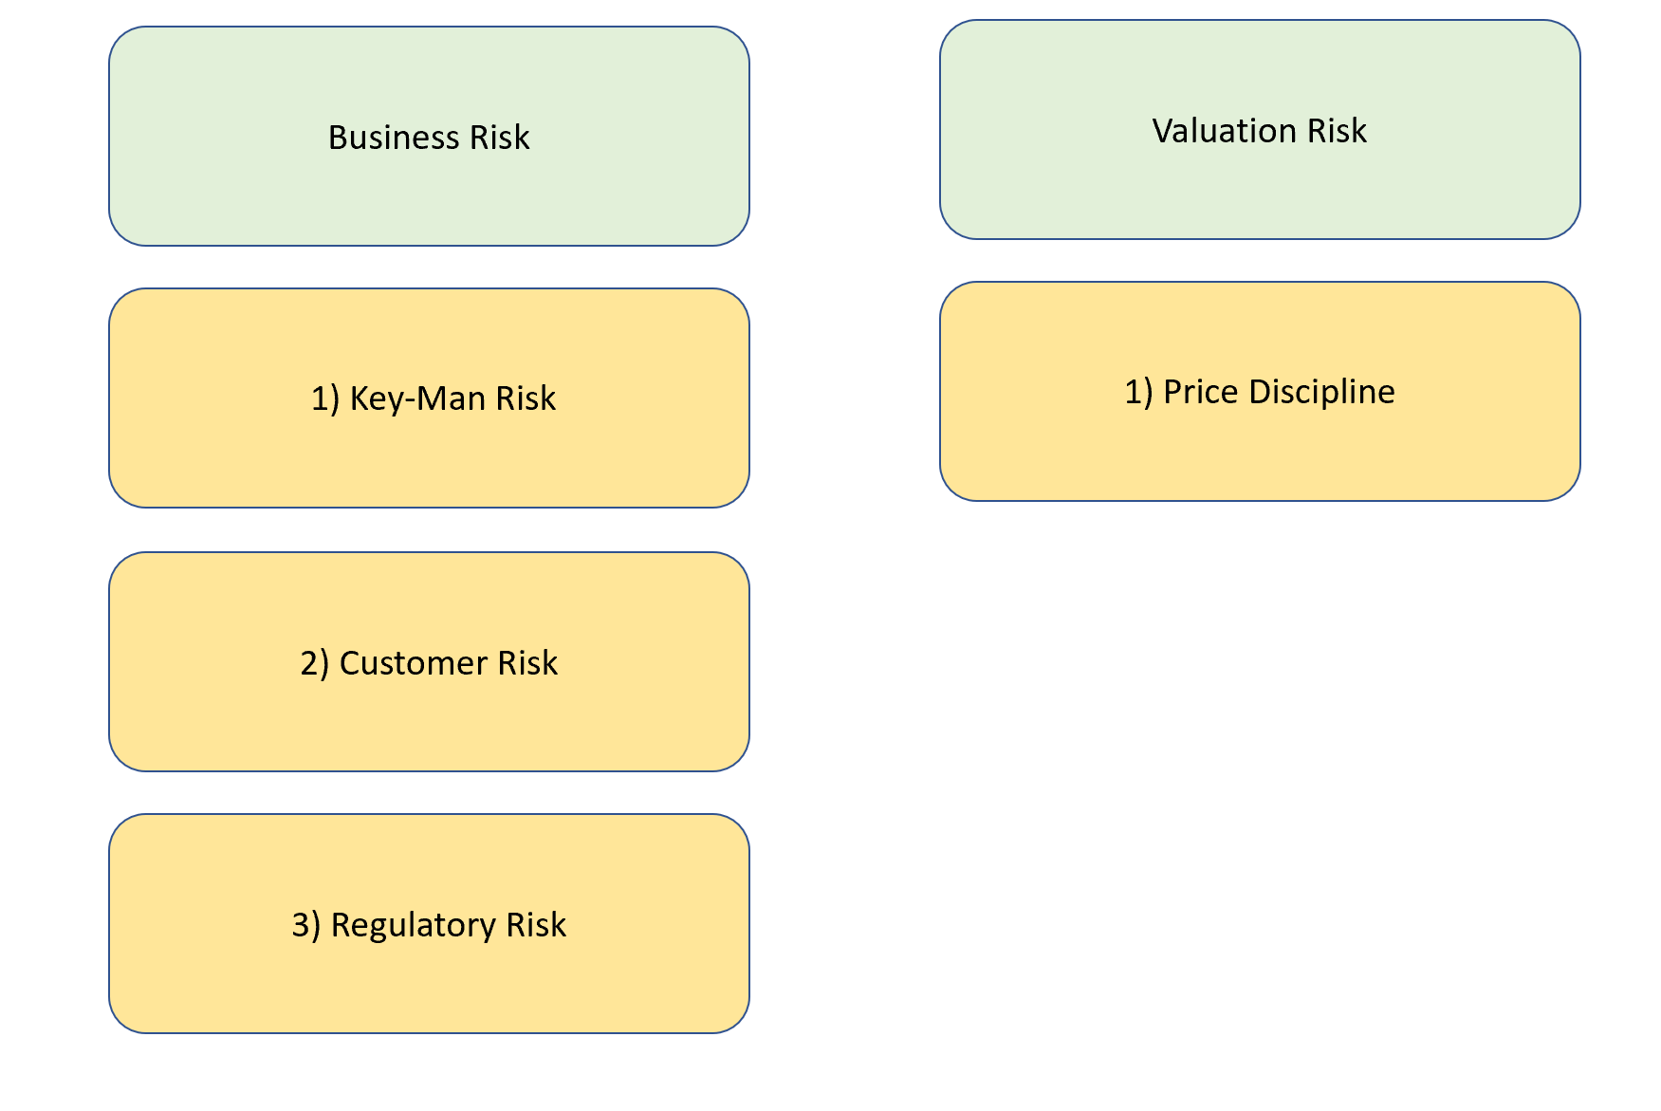

2.4.1 Key Man-Risk
- What is a key man risk?
  - The entire business has one employee only.
  - The entire business is heavily dependent on the founder or a particular key employee
  - The entire business is focused on selling keys and nothing else.

- Which businesses below are most likely to have key man risk?
  - McDonald’s
  - Tesla
  - Apple
  - Microsoft

- The entire business should never be dependent on a single individual. There must be a system to mitigate key-man risk.

Can you think of some ways to tackle and minimize key-man risk in a company?
(e.g., A position may be shared by several people, or each individual can be empowered to perform different roles / tasks / functions for cross-coverage.)

- Think of Microsoft. Ask yourself: If an important management or team member leaves the company, can Microsoft continue to operate as usual? Explain your answer.

- Which of the following businesses has more key-man risk? Circle the correct answer. Share your thoughts below.

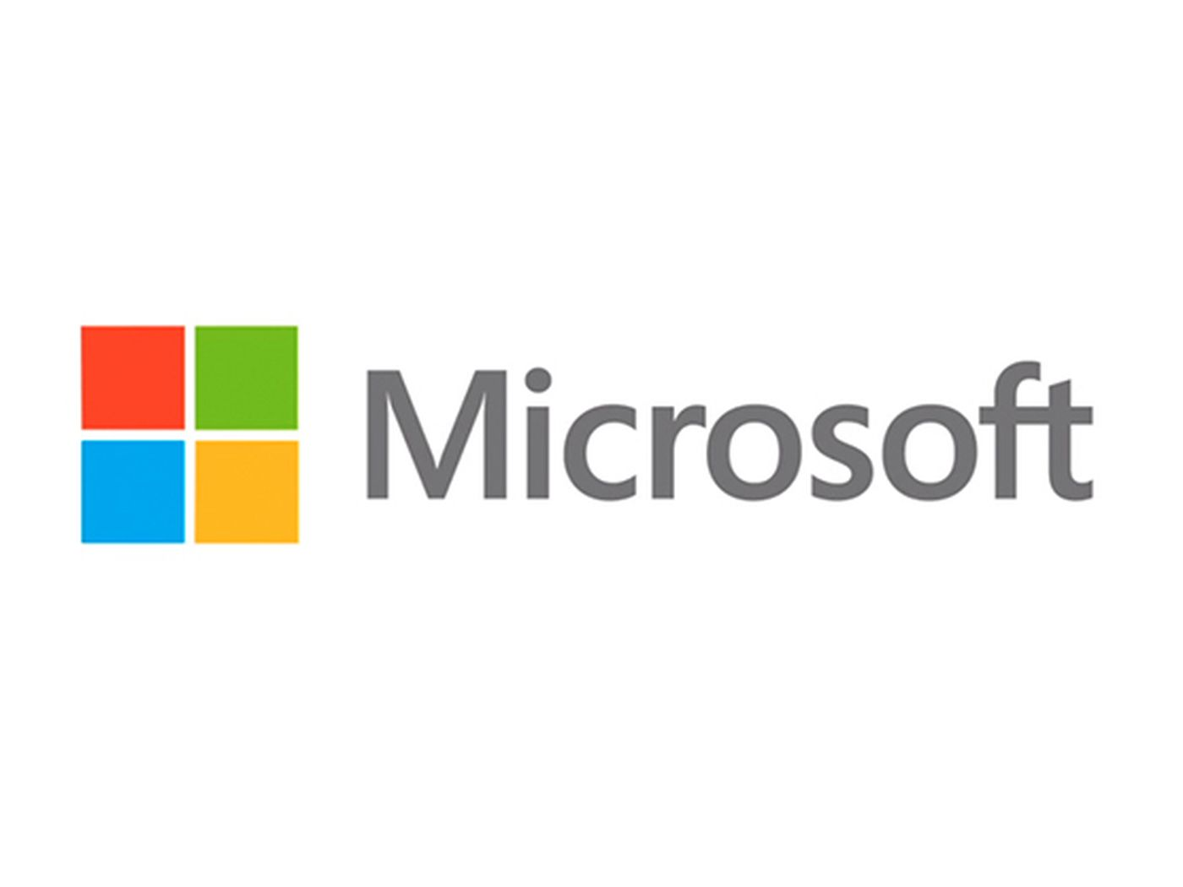

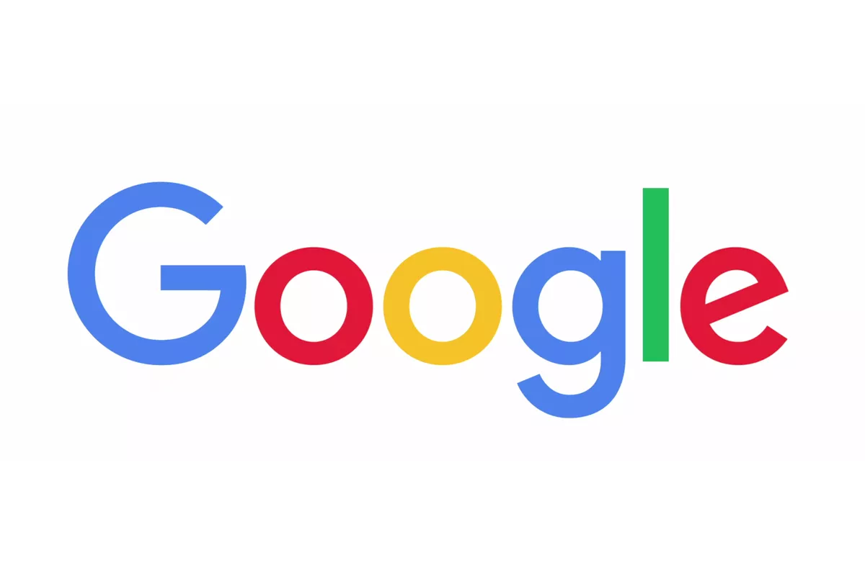
Architect Consultancy Services

Answers:
- a
- b
- To reduce key man risk in the company, the founder should empower his team members with the authority to make decisions on behalf of the company. Instead of holding power, the founder should bring along his core management team along with important client meetings. It is important to delegate job functions too. A successful founder is one where even without his or her involvement, the business runs well because there is a management system in place.
- If a core team member of Microsoft leaves, the business would still operate as usual because it is a software company. The consistency of the product delivered is not dependent on any single person since it is standardised. The business may have to delay some of their growth plans, but the business will move on just fine.
- The architect consultancy services. You cannot scale an architect service because each problem requires an unique solution. A creativity based business is difficult to scale.

2.4.2 Customer Risk

- What is customer concentration risk?
  - A customer which constitutes a big portion of revenue to the company
  - A customer which does not pay up on time.
  - A customer which buys too little from the company
- What is considered high customer concentration?
  - More than 10% of revenue
  - More than 5% of revenue
  - More than 20% of revenue
  - More than 50% of revenue

- What are some key words we can search in the Annual Report (10-K) of the company?
  - good customers
  - 10% or more
  - bad customers
  - slow customers

- Why should a company NOT have customer concentration?
  - The business is not recurring.
  - The business is not profitable.
  - The business will suffer revenue decline if a customer decides to leave.
  - The business cannot meet the demands of the customers.
- Task: Search EDGAR on Google.
(EDGAR, the Electronic Data Gathering, Analysis, and Retrieval system, performs automated collection, validation, indexing, acceptance, and forwarding of submissions by companies and others who are required by law to file forms with the U.S. Securities and Exchange Commission)

You should be taken to https://www.sec.gov/edgar/searchedgar/companysearch.html
- Search [company name]
- Search for 10-Q or 10-K and click on documents
- Search for terms like: “concentration”, “10% or more”, “more than 10”

- Which company has the most customer concentration risk, Par Technology, Galaxy Gaming or PaySign? Also, let’s think deeper, is having customer concentration risk really bad, or it could be a positive thing if the customer is a well-established company? Share your thoughts!

- No sales to an individual customer or country other than the United States accounted for more than 10% of revenue for the three months ended December 31, 2019 or 2018.
Figure X: Screenshot from Microsoft Quarterly Annual Report
What do you think about Microsoft’s Customer base? Does it have a low or high customer risk?
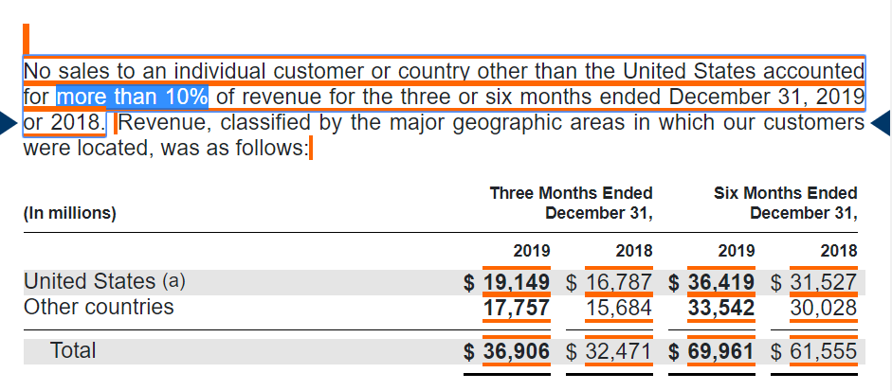

Answers:
- a
- c
- b
- c
- For Galaxy Gaming: Client A (9.2%) and Client B (10%),
Par Technology: McDonald's (16%), Yum Brands (25%), Diary Queen (13%)
PaySign: not disclosed
- Having a big customer may not necessarily be bad if the big customer is a well established one. For example, Hypebeast had a customer called Louis Vuitton. Louis Vuitton’s reputation precedes itself. It is a global company with a strong balance sheet. The risk of Louis Vuitton defaulting on their payments is extremely low. A big customer is able to provide huge revenue growth potential to the company. In some cases where the big customer’s identity is unknown, check out their investor presentations or call up the company to check. When in doubt, it is better to avoid companies with huge customer concentration risk.
- The risk is very low. Microsoft serves a wide range of industries including governments of different nations. It should have a very low customer concentration risk.

2.4.3 Regulatory Risk
- What are industries which are more prone to heavy regulations?
  - Pharmaceutical industry
  - Software industry
  - Food industry
  - Furniture industry

- What are some side effects of heavy regulations?
  - Restriction on sales of products and services.
  - Stoppage of production if it does not meet regulations
  - Lower sales
  - All of the above

- What are the products that have associated regulatory risk?
  - Health-related (medicine, sugary drinks)
  - Essential goods (defence, power, utility, water)
  - Entertainment (gambling)
  - All of the above

Answers:
- a
- d
- d

2.4.4 Valuation Risk

- What is market capitalisation?
  - the price of the entire company that changes every day, depending on the share price.
  - the growth of the market which the company operates in.
  - the strength of the money currency

- When a company has a high share price, it means it is expensive. True or false?
  - False, a company could have higher earnings which supports the higher share price.
  - True, a high share price means it is expensive.

- What is the formula to calculate market capitalisation?
  - cash in the balance sheet multiply by number of shares outstanding
  - operating profit divided by number of shares outstanding
  - latest share price multiply by number of shares outstanding

- ________ is a measure of a company's real price. It captures the real price of the entire company after adjusting for the debt and cash amount in the company’s balance sheet.
  - Equity Value
  - Market Capitalisation
  - Enterprise Value
  - Total Value
- What is the formula of Enterprise Value?
  - Market Capitalisation - Debt + Cash
  - Market Capitalisation + Debt
  - Market Capitalisation + Debt - Cash
  - Market Capitalisation - Cash
- When we are doing valuations, we are looking at something called price multiple. Which of the following is a price multiple?
  - Enterprise Value divided by EBIT
  - Operating Profit divided by Revenue
  - Net Debt over Equity

- Which of the following statements are true?
  - At times, even when we pay higher price multiples for quality companies, we would still make a lot of profits because those companies continue to demonstrate growth.
  - When we like a company, we should buy it at any price.
  - As an investor, our aim to buy companies with the lowest EV/EBIT. When we buy companies with EV/EBIT, we would make money all the time.
- “Price is what you pay. Value is what you get.” -- Warren Buffett

I have an envelope, and inside it is a share of Flipbird Corporation. Flipbird Corporation is a business with a Return of Equity of 30%, Net Debt to Equity of below 30%, and the founder is very optimistic about its future. In fact, they just won a major contract with a big client. Currently, I am selling the envelope for $10. Would you buy the envelope? Yes or no? Share your answer.

- I have a share of Rockstar Corporation, whose intrinsic value is $20. Rockstar Corporation has Return of Equity of 30%, Net Debt to Equity of below 20%, high Life Ratio and low Vampire Ratio. It also won a huge contract with an overseas client, which was reported in the news. Currently, I am selling the company at $10. Would you buy the company? Yes or no? Share your answer.

- Why do you need to understand the intrinsic value of the company? What happens if you are able to buy the share at a good price versus a bad price? Write down your thoughts.

Answer:
- a
- a
- c
- c
- c
- a
- a

- No, I would not buy the company. Although it is a good company, I do not know the intrinsic value of the company. Although it is selling for $10, the company might be worth $5 per share or even less! Here, we only know the share price, and we don’t know its intrinsic value.

- Yes, it meets the quantitative requirements. It is different from the previous question because the intrinsic value is $20 while it is selling for $10 (a 50% discount).

- When we know the valuation range of the company, it protects us from fear of missing out. This keeps us from chasing after the share price if it has shot up way above the actual value of that company’s stock. Likewise, in times of crisis, when the share price is below valuation, it increases our margin of safety. It affords us the confidence and a trigger point to buy when everyone is selling in panic.

3.1.1 Growth Mindset

- Why do we require a company’s management to have a growth mindset?
  - it is define the growth plans with credibility and execute it
  - it is to create publicity and hype for the company
  - it is to increase the share price of the company
- Where can you find evidence of growth plans?
  - earnings commentary
  - management interviews (Youtube or company’s website)
  - shareholder’s letters
  - all of the above

- How do you find the company’s investor relations website on Google?
  - Search for “[company name] website”
  - Search for “[company name] results”
  - Search for “[company name] investor relations”

- Search for a company’s investor relations website and go to their press release. You could visit the earnings announcements too. Look for any signs of growth mindset mentality from the management. Are growth plans articulated clearly? Share your answers!
(Some recommendations: Paypal, Amazon.com, Ross Stores)

Answers
- a
- d
- c
- No right or wrong answers.

3.2.1 Ability to Execute

- Why do you need to assess a management’s ability to execute?
  - It is to determine whether the management has credibility to execute his growth plans.
  - It is to determine whether you like him or her enough
  - it is to determine whether the company’s products are reliable
- How do you find out who is the CEO of a particular company? What do we search for in Google?
- Search for “[company name] ceo”
- Search for “[company name] board of directors”
- Search for “[company name] address”
- A and B only.
- Search this on Google “Microsoft CEO”, when did Satya Nadella become the CEO of Microsoft?
- 2009
- 2015
- 2013
- 2014

- Let’s do a simple practice on Microsoft:
- Search Google for “Microsoft Morningstar key ratios"
- Look out for the growth rates of the business.
- Look at the operating income during the period where Satya Nadella is/was running the company. Is it flat or growing?
- Look at the operating margin. Is it flat or growing?
- Research on Microsoft on Morningstar using the above steps. What do you think of Satya Nadella? Share your findings about Satya Nadella’s “ability to execute”?

- Search Google for “Macy’s Morningstar key ratios"
- Look out for the growth rates of the business.
- Look at the operating income during the period where Jeffrey Gennette is/was running the company. Is it flat or growing?
- Look at the operating margin. Is it flat or growing?

- Research on Macy’s on Morningstar using the above steps. What do you think of Jeffrey Gennette? Share your findings about “ability to execute” for Microsoft.

Answers:
- a
- d
- d

  - Since Satya Nadella became the CEO of Microsoft, he has kept operating profit margins above 30% (except for 2016 and 2017). He has also nearly doubled the operating profit of Microsoft from USD 27.9 billion to USD 50 billion approximately.
  - Jeffrey Gennette became CEO of Macy’s in 2017. The operating profit of Macy’s in 2017 is USD 1.9 billion. For FY2020, the operating profit is USD 1.2 billion. The operating profit has not been increasing and in fact has deteriorated. In terms of ability to execute, it is not visible.

3.3 Skin In the Game
- What does skin-in-the-game refer to?
  - does the CEO reports to work every day
  - does the CEO’s family members work in the company
  - does the CEO has a portion of his net worth tied into the business

- What is the percentage of shareholdings we prefer our CEOs to hold in their companies?
        - More than 5%
        - It does not matter
        - More than 10%
        - IIt depends on their preference, it is not up to us to decide.

- Why is it important for the CEO to own a significant amount of shares in the company?
  - He/she will think in the best interests of the shareholders
  - He/she will focus on building the business with a long term horizon
  - He/she will make decisions carefully
  - All of the above
- Where can we find information about the share ownership of the management?
  - Marketscreener.com
  - Proxy statement, otherwise known as Form DEF 14A
  - It is not disclosed anywhere
  - Only A and B is correct

- "Founder-led companies tend to do better than hired management companies as they are more purpose driven". Do you agree with this? Share your thoughts below!

- Let’s learn how to check management shareholdings of these companies -- Catasys, Intelligent Systems Corporation and PaySign.
Go to https://www.marketscreener.com | Type in the company name: e.g., PaySign
OR
Search “[company name] DEF14A” on Google
Click on “Company”, and scroll down for the percentage % owned by the management.
Does the CEO have a high ownership percentage in the business? (we look for > 10% CEO ownership for USA and Asia-Pacific companies)

Answers:
- c
- c
- d
- d
- Yes, for founder-led companies, they tend to be more purpose-driven. The founder himself/herself would spend more time talking to the customers to understand their satisfaction level. The culture of the company could be more family-centric which fosters employee trust and loyalty. In terms of corporate spending, it is likely that the company will be frugal and careful too. All these would lead to cost efficiency and higher productivity.
- For Catasys, Terren Peizer owns 55%.
For Intelligent Systems Corporation, Leland Strange owns 17%
For PaySign, Mark Newcomer (CEO) owns 19%
All of the CEOs have high ownerships in the companies.

3.4 Purpose

- What does purpose refer to?
  - A founder’s motivation for growing the business beyond monetary gains
  - The topics that employees talk about on a daily basis
  - The ability for a company to get discounts from their suppliers

- How can you find out more about the culture of a company?
        - Go to Glassdoors
        - Go to Youtube and search for their videos
        - LinkedIn
        - All of the above

- What are some of the key words we can use to search on Google to know more about the founder?
  - [company name] [ceo name interview]
  - why did [founder name] start [company name]
  - [company name] [board of directors]
  - All of the above

- Circle the desirable traits and cross out the undesirable traits of management.

mission-focused, purpose-led | treats employees as expenses | customer-focused, not competitor-focused
frequent changes in CEO/CFO/auditors | reckless corporate spending | over-charging customers
treats employees as partners | think win-win and long-term | owns too little shares

Answers:
- a
- d
- d

mission-focused, purpose-led O | treats employees as expenses ☓ | customer-focused, not competitor-focused O
frequent changes in CEO/CFO/auditors ☓ | reckless corporate spending ☓ | over-charging customers ☓
treats employees as partners O | think win-win and long-term ☓ | owns too little shares ☓

Draw a mindmap of what you have understood from this module of qualitatively analysing a business. Again, make this a masterpiece you will continue to reference as you grow your portfolio!

Apply the PACS GASP checklist criteria from the Qualitative Analysis modules to the companies on your list from earlier.
Once you have completed this, look only at companies that meet the Quantitative and Qualitative checks. Congratulations, this is your Watchlist of investible companies.
WAIT!

This is NOT a list of companies to buy or invest in, right now. It’s a WATCHLIST. It’s part of your PLAN for when the opportunity comes your way! The final step is to DECIDE on your entry price, and how much of your portfolio this company should occupy.

